Pantry Tracker Project

Setting up the project.

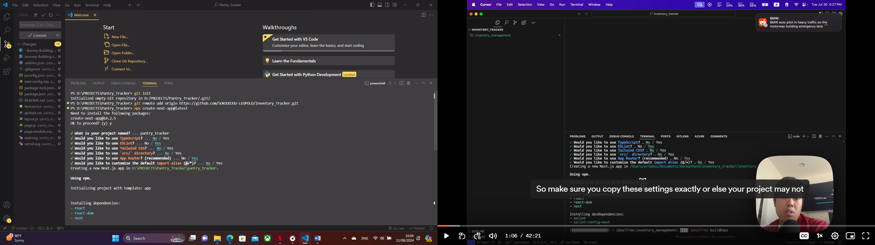

Use the command below to run the basic app and see if the configurations were well done:

npm run dev

You can add additional dependencies like material-ui

npm install @mui/material @emotion/react @emotion/styled

We also want to install firebase

npm install firebase